Assignment: **Troubleshooting and Helpdesk**

Section 1: Multiple Choice

1. What is the first step in the troubleshooting process?

Ans: B) Identifying the problem

1. Which of the following tools is commonly used to diagnose hardware  
   issues by testing electrical connections?

Ans: C) Multimeter

1. Which of the following best describes the purpose of a VPN (Virtual  
   Private Network)?

Ans: A) Encrypting network traffic to prevent eavesdropping

1. Which Windows utility can be used to view system logs, monitor  
   performance, and diagnose hardware and software issues?

Ans: C) Event Viewer

**Section 2: True or False**

1. Safe Mode is a diagnostic mode in Windows that loads  
   only essential system services and drivers, allowing users to  
   troubleshoot and fix problems with the operating system.

Ans: True

1. A system restore point is a snapshot of the computer's  
   system files, registry, and configuration settings at a specific point in  
   time, which can be used to revert the system to a previous state if  
   problems occur.

Ans: True

1. Ping is a command-line utility used to test network  
   connectivity by sending ICMP echo requests to a target device and  
   waiting for ICMP echo replies.

Ans: True

**Section 3: Short Answer**

1. Describe the steps involved in troubleshooting a computer that fails to  
   boot into the operating system

Ans:

1. Ensure the computer is receiving power and the power light is on.
2. Check if the boot order is set to boot from the correct device.
3. Check if the bootable media is properly inserted and recognized by the computer.
4. Check if the system BIOS is set to boot from the correct device.
5. Press F2, F8, F12, or Delete keys to access the BIOS setup menu.
6. Perform a clean boot by pressing Ctrl + Alt + Del keys.
7. Replace the hard drive if it is faulty.
8. Replace the motherboard or CPU if necessary.
9. Replace the RAM or power supply if necessary.
10. Replace the video card or monitor if necessary.
11. Replace the network card or network cable if necessary.
12. Replace the hard drive if necessary.

**Section 4: Practical Application**

1. Demonstrate how to troubleshoot network connectivity issues on a  
   Windows computer using the ipconfig command.

Ans:

1. Open the Control Panel.
2. Click on "Network and Internet" and then click on "Network and Sharing Center".
3. In the "Network and Sharing Center" window, click on "Change adapter settings".
4. Right-click on the network adapter you are using and select "Properties".
5. In the "Network Connections" window, select "Internet Protocol Version 4 (TCP/IPv4)" and click on "Properties".
6. In the "Internet Protocol Version 4 (TCP/IPv4) Properties" window, select "Obtain an IP address automatically" and click "OK".
7. 7. Click "OK" to close the "Network Connections" window.

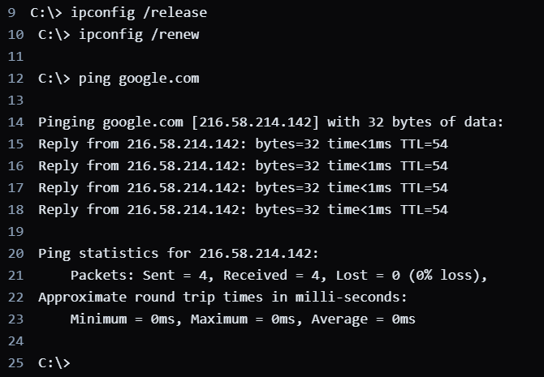

* 1. Open Command Prompt or PowerShell on Windows.
  2. Type ipconfig /all and press Enter to see network configuration details.
  3. Look for errors indicating a disconnected or faulty network adapter.
  4. If disconnected, connect using a network cable.
  5. If errors persist, reset the network adapter with the command:

>netsh int ip reset

* 1. Restart your computer after resetting the network adapter.
  2. Check the network connection.
  3. If the issue continues, update the network drivers from the manufacturer's website.
  4. If the problem persists, contact your network administrator or ISP for help.

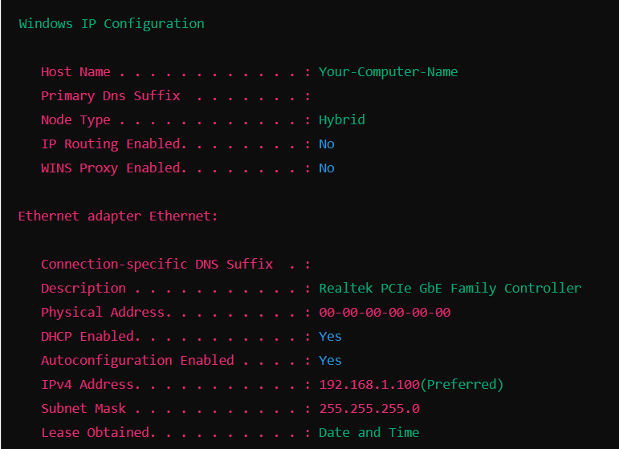

**Section 5: Essay**

1. Discuss the importance of effective communication skills in a helpdesk or technical support role.

Ans:

Effective communication skills in a helpdesk or technical support role are crucial for several reasons. Clear communication ensures accurate problem understanding, as technicians need to ask the right questions and listen actively; for instance, identifying whether a user’s internet issue is due to a router or service provider problem. Building trust and rapport with users makes them feel heard and valued, improving their overall experience.

Explaining solutions in simple terms helps non-technical users grasp the steps needed to resolve their issues, such as guiding them through resetting a password. Efficient problem resolution is achieved through clear instructions, reducing misunderstandings and speeding up the process. Empathy and patience reduce user frustration, making stressful situations more manageable. Proper communication aids in documentation, ensuring accurate records of issues and solutions. It also enhances team collaboration, as clear information sharing is essential for consistent support. Effective communication reflects professionalism, showing users that the support team is competent and reliable. Lastly, gathering user feedback through good communication helps improve support services, highlighting areas for training and development.